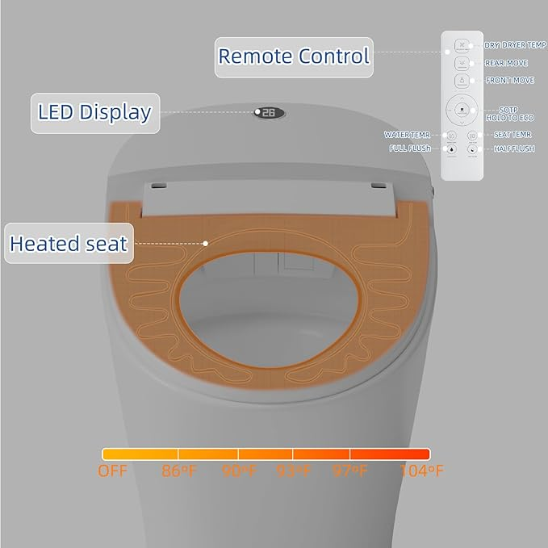

$279

Smart Toilet,One Piece Bidet Toilet for Bathrooms,Elongated Toilet With Warm Water,Foot Sensor Operation，Dual Auto Flush,Heated Bidet Seat,Night Light,Auto Smart Toilet With Led Display